**Merging two repositories with git**

This document serves as a guide for merging two previously unrelated git repositories. This can be more complex than merging branches in a single repository, but can be done with a similar git workflow.

For this guide, I will be merging the repo named “test1” into the repo named “test2”.

Repo “test1” will remain unchanged.

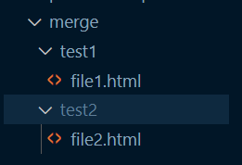

First, in a bash terminal, navigate to the repo you wish to merge into (in this case, “test2”). Once in this directory, execute the command:

| git remote add <repo to be merged> <remote path> |
| --- |



This will stage “test1” to be added to “test2”

Next, execute the command:

| git fetch <repo to be merged> |
| --- |

If successful, this message will display:

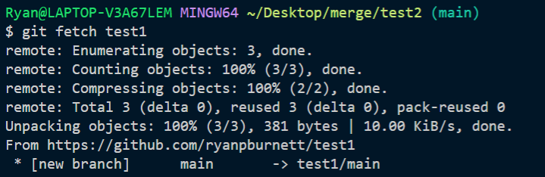

To complete the merge, execute this command:

| git merge -–allow-unrelated-histories <repo to be merged>/<branch> |
| --- |

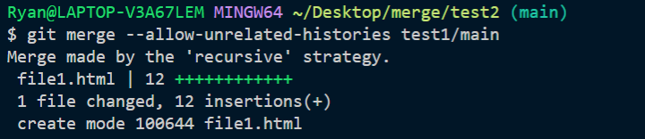

Afterwards, the repos will look like this, in this example:

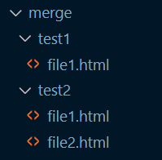

The --allow unrelated-histories flag is important, since otherwise git will have difficulty managing history conflicts. If this flag is not present, this error will occur:

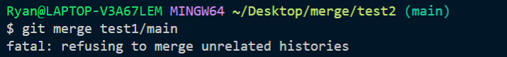

**Committing changes**

After this, a normal commit can be made as usual, from the same directory:

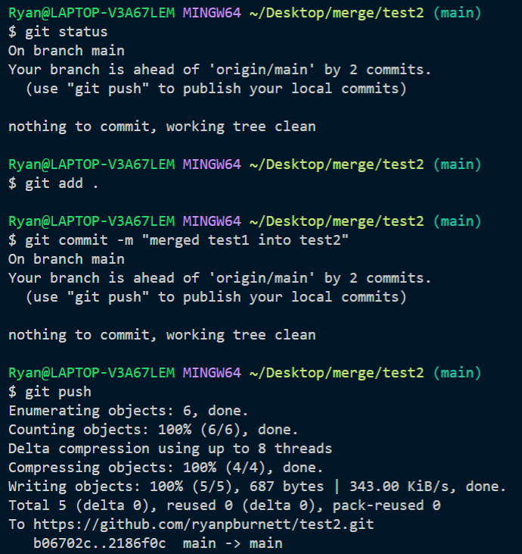

After this, all files from both repos should be successfully merged.

**Adding new changes**

In the event that more changes happen in the first repo, that need to be reflected in the second (joined) repo, the following commands can be executed:

| git fetch <first repo> git merge <first repo>/<branch> |
| --- |

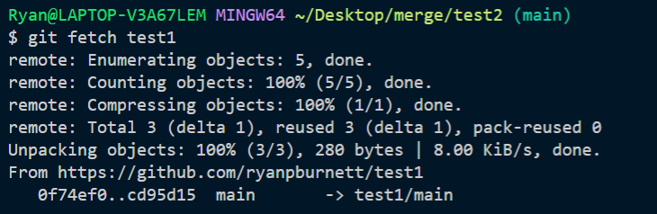

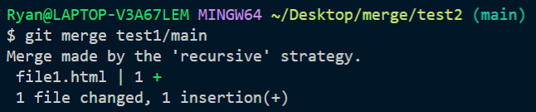

After this, the usual commit workflow described above will commit these changes remotely.

**Command workflow for merging repos:**

| git remote add <repo to be merged> <remote path> |
| --- |

| git fetch <repo to be merged> |
| --- |

| git merge -–allow-unrelated-histories <repo to be merged>/<branch> |
| --- |

| git add . git commit -m "message" git push |
| --- |

**Command workflow for adding new changes:**

| git fetch <first repo> git merge <first repo>/<branch> |
| --- |

| git add . git commit -m "message" git push |
| --- |